***MATERIALS***

* Stairs/ step
* Stopwatch
* Heart rate monitors

***PROCEDURE***

**WARNING:** If at any stage during the exercise period the subject experiences any discomfort, stop the activity immediately and tell the teacher

* Draw up a suitable table to collect heart rates of at least 3 different test subjects. The heart rate will be measured at 0 minutes, 2 minutes, 4 minutes and 6 minutes.
* Collect the resting heart rate of the test subject.
* Test subject is to use stairs or steps to complete step-ups and step-downs for 2 minutes. Subject is to maintain a consistent beat (1-2-3-4) (**see diagram one on next page**).
* At end of 2 minutes measure subject 1’s heart rate.
* Repeat for test subject 2 and 3.
* Repeat steps 3 and 4, stepping for 4 minutes and 6 minutes each.

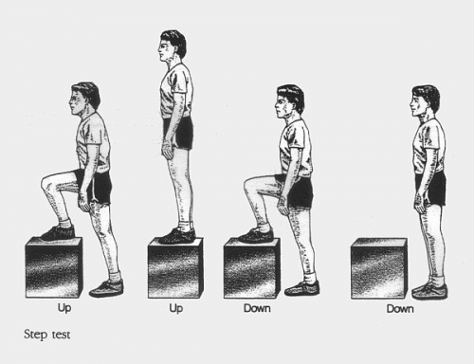**Diagram 1**: Picture showing one cycle of the step test.